Creating ADA Compliant Blackboard Courses

Introduction
This tutorial will focus on making your Blackboard course site accessible.
First, let’s clarify what we mean by “Blackboard course site.” This refers to any Content Item, Folder, Discussion Forum, Blog, Journal, Assignment, or Assessment—anything that you may add, upload, or post in Blackboard.
Remember that any materials you create outside of Blackboard also should be ADA compliant. This means you’ll need to review each of your Word and PowerPoint files (in addition to other types of files you may use), as well. See our tutorials for Word and PowerPoint to learn how to bring them into compliance. If you use other types of files, contact Distance Learning to learn how to make those files accessible.

What We’ll Cover
We’ll visit each of the following items to make sure you know how to make your Blackboard course site as accessible as possible.
- Heading Styles
- Images
- URLs
- Tables
- Your Course Menu
- Audio and Video Files
- Testing Considerations

Heading Styles
Use heading styles if information you are posting in an Item is long and has subheadings or sections. This will help students using screen readers more easily navigate your Blackboard Course.

Format Text Using Heading Styles
- Select the text
- Select the heading style that you want to use from the Format drop-down menu (see the screenshot below).
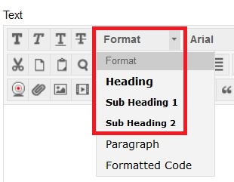
Note that you can change the text to have any appearance you want after making it a heading, subheading, or paragraph. However, you should avoid using underlining, as that traditionally designates a link on a web page.

Images
If you use images, or add shapes or other objects, to content that you create on Blackboard, screen readers do not interpret them. Instead, the screen reader says, “IMAGE.” It does not tell the student using a screen reader what the image is or why it’s important to the course. You need to add a meaningful description, or “alt text,” to properly format images, graphs and charts that you may create or place in Blackboard
When you share images in Blackboard, they need to have descriptive text to be accessible. However, the method for making them accessible differs depending on the complexity of the image and how much verbiage it takes to describe it. There are three ways: add the description when you insert the image, add a description under the image after you insert it, or attach a description in a document under the inserted image. Let’s look at all three methods and when you might want to choose one over another.

Adding a Meaningful Description to an Inserted Image
This method is best for simple images, such as cartoons. To add a meaningful description to an image when you insert it in Blackboard, follow these steps:
- Click the Image Icon in the tool bar of the text editing box
- Click Browse to find and select your image
- Type the meaningful description into the Image Description field (see the screenshot below).
- Click Insert in the bottom right corner.
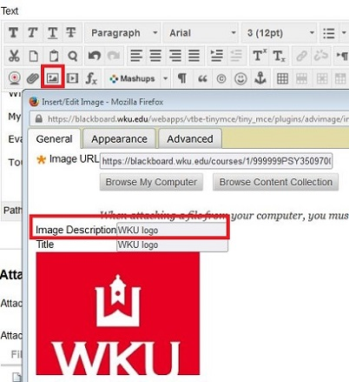
You can also add a description to an image you have already inserted in your Blackboard course using almost all of the same steps.
- Click the image to select it
- Click the Image icon
- Add your meaningful description to the Image Description field
- Click Update
The other two options for adding descriptions are best for more complex images that need greater description than the Image Description field will allow. When you insert those images, you should type in “Refer to image description” in the Image Description field so that students using screen readers know a description is available.

Adding a Description under an Inserted Image
If you would like for the image to display to students and have the description display underneath (like a caption), follow these steps.
- Click the Image icon in the tool bar of the text editing box
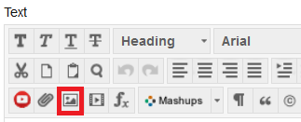
- Select your image using Browse
- In the Image Description field, you should type in “Refer to image description” so that students using screen readers know a description is available.
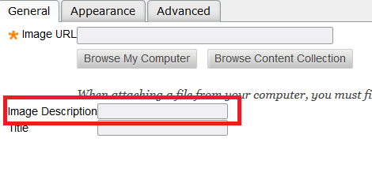
- Click Update in the bottom right corner.
- After adding the image into Blackboard, simply type in a description of the image underneath it.
See the image below for an example of what this would look like in Blackboard.
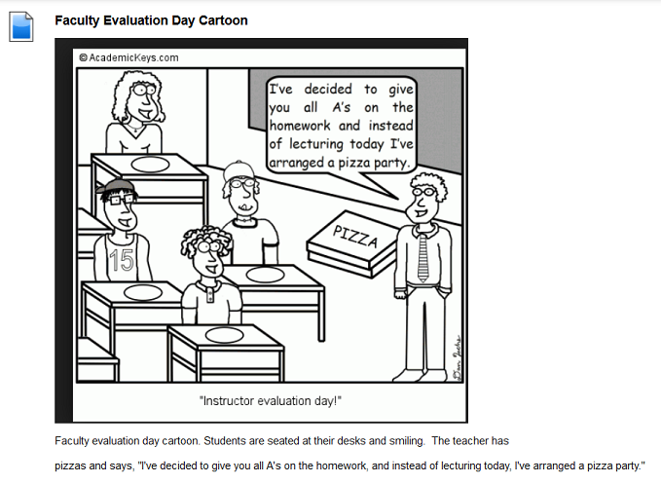

Attaching a Meaningful Description under an Inserted Image
For complex images, another option is to type out the explanation in a Word document and then attach that description under the image. See an example below:
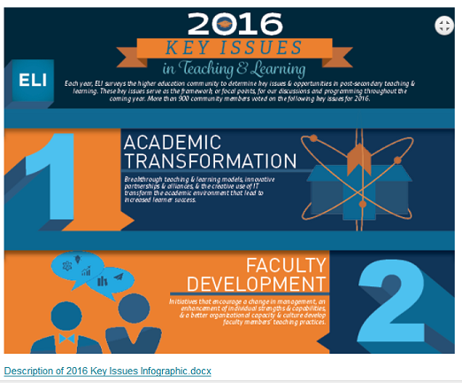
To attach the description document, first, insert your image. In the Image Description field, type “Refer to Image Description Document.”
Then, to attach the document under the image, click under the image, and follow these steps:
- Click the Insert File icon.
- Browse and find your saved document.
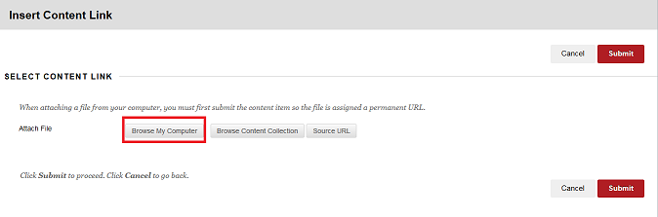
- Once it is selected, type in a short description, such as “description of” and the name of the image in the Alt-Text field. See the example below:
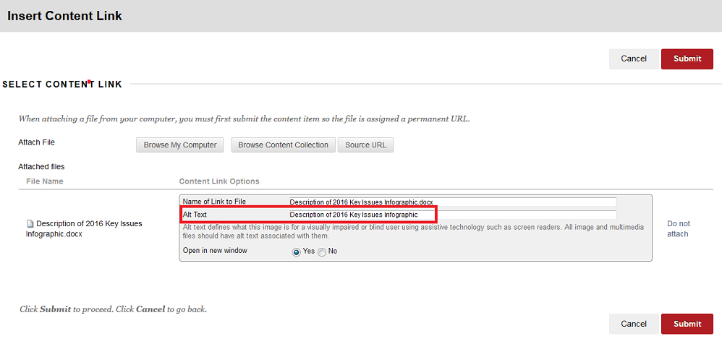
- Click Submit.

Web Addresses (URLs)
A URL is a web site address—a uniform resource locator. Screen readers will attempt to read URLs, and as we know, many URLs are not meaningful or readable! Always provide meaningful descriptive text for links so that students who use readers know where they are to be directed (most readers say “Link” and read the descriptive text). An example of descriptive text link is Western Kentucky University website instead of http://www.wku.edu/. Following the steps below to provide descriptive text instead of hyperlinks. Formatting URLs in Blackboard is slightly different than doing it in MS Office programs.

How to Create Descriptive Text for Links:
- In the text editing box, type the descriptive text where you want it to display
- Select the text and click the Insert/Edit Link icon
- Type or Paste the link in the Link Path filed
- In the Target field, select Open in New Window (_blank) in the drop-down menu
- Type a title in the Title field
- Click Insert button on the right-bottom of the dialogue box.
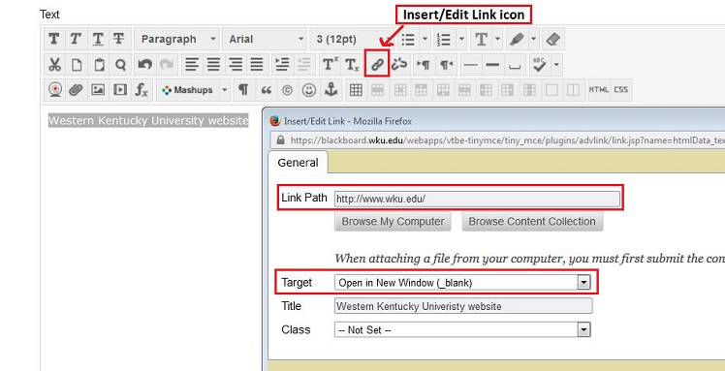

Tables
Screen readers read tables one field at a time, one row at a time. Read your tables aloud to yourself in that manner. When read that way, a table might not make as much sense as it should. If that is the case, consider not using a table or formatting the information in a different way. Avoid using a table when bullet points will convey the same message.
Also consider breaking long tables up into multiple smaller tables across slides to aid students who use screen readers so that they can more easily process the information they hear when a table is read to them.
There are two changes you’ll need to make to your tables to make them be accessible: add a meaningful description or a summary (alt text), and identify the header row.

Add a Meaningful Description to a Table
- Select the table
- Click the Insert/Edit table icon in the tool bar of the text editing box, a dialogue box will appear.
- Click Advanced tab
- In the Summary field, type a description or summary of the table (see the screenshot below)
- Click Update in the bottom right corner
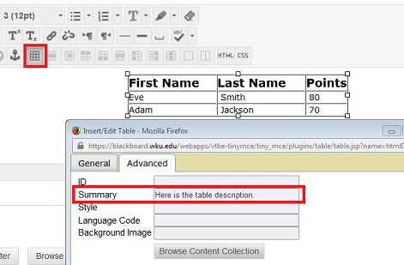

Identify the Header Row of a Table
You must also identify the header row. Students who use screen readers have the option to have the reader repeat what the header row says while they are listening to a table if the header row is marked.
- Select the header row of the table
- Click the Table Row Properties icon in the tool bar of the text editing box, a dialogue box will appear
- Select Header from the drop-down Row Type menu (see the screenshot below)
- Click Update at the bottom right of the screen
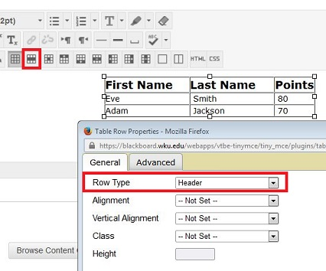

Your Course Menu
Although there is more information about the use of colors later in this course, it is important to think about how you will use color in your course menu in Blackboard.
First, carefully consider the use of high contrasting colors when choosing a course menu color. It’s much easier to read white text on a black background than to read light red text on a dark red background. See below for examples.
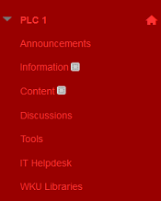
The screenshot above is an example of poor color contrast.
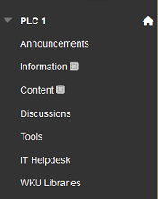
The screenshot above is an example of good color contrast.
In addition to considering colors when setting up your course menu, contemplate if you want to use just text or if you prefer to use a button. Buttons can be hard to read if they have a pattern or texture in addition to the text. See an example of some less than optimal choices for buttons below:
If you want to use a button design, consider using a “Striped” Blackboard design that uses colors only in the button corners like the below image:

Audio or Video Files
Videos and audio files can be a great resource as required or optional course material. Written transcripts or closed captions for audio files or videos need to be made available for those with hearing impairments perceive the information. If you have been notified by the Student Accessibility Resource Center that a currently enrolled student is in need of special accommodations, please go to Transcribing Services web page (https://www.wku.edu/online/faculty/transcribe.php) and fill out the priority request form to submit a transcribing request. Distance Learning’s transcribing services will work to ensure all course related videos are transcribed or captioned. However, our transcribers are limited, so courses with students who need an accommodation are given a priority designation.

Testing Considerations
Because of limitations within Blackboard, if tests have video, audio, matching, and/or hot spot questions, alternative questions/tests should be provided.

