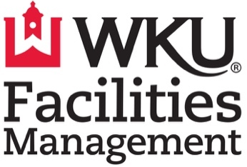

REMINDERS:

- Wear comfortable clothes and close-toed shoes
- Each clean-up requires a 3–4-hour commitment.
- Come with a positive attitude ready to work!

COMPENSATION:

The compensation for this clean-up is $1000. Facilities Management will pay this amount and cover up to a 3% processing fee on an approved payment platform (Venmo, Square).

TASKS:

- Pickup and sort trash, recycling and liquids.
- Sweep or blow the entire inner stadium: between the seats, under the seats, the isles and the stairs.
- Spot mop, scrape sticky residue, and sanitize hand rails.
- Move all trash cans, recycling bins, recycling carts and compost bins outside of the stadium.

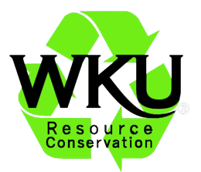

STADIUM RECYCLING PROGRAM
PARTICIPATION CONTRACT

OVERVIEW:

The Diddle/Smith Recycling Program gives student and community organizations the opportunity to fundraise by cleaning Smith Stadium or Diddle Arena. By signing this contract, your organization agrees to the goals and expectations of the program.

PURPOSE:

Promote recycling at the games, deliver a high-quality cleaning job, properly recycle all materials, record accurate data of all waste stream weights and provide friendly customer service to fans.

AGREEMENTS:

All participants must agree to the following program expectations. Please have a representative of your organization initial by each agreement.

- Volunteers will be dressed appropriately to participate in the program.

- Volunteers will arrive on-time to participate in the program.

- Volunteers will stay until the stadium is clean and approved by a custodial supervisor.

- This organization will provide the number of volunteers listed on the submitted volunteer list. If this number is less than 30, we understand that Facilities Management will select an organization to partner with our organization during the program and the donation will be split proportionally. (Ex. Group A has 10 volunteers and Group B has 25 volunteers. The groups will split the donation $286 and $714).

- A representative of our organization will coordinate with the Facilities Management office to receive payment within 21 days of participating in the program (by). This may require physically going to the office with a square reader.

If you understand the program expectations, please sign below:

SIGNATURE ORGANIZATION

Failure to meet these agreements may result in decreased funding or ineligibility to participate in future clean ups.

