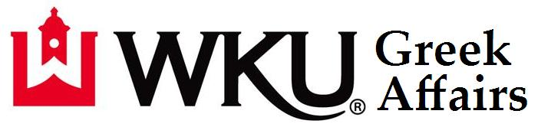
2022 - 2023 Annual Report
Introduction
The 2022-2023 school year was a highly productive year for the fraternity and sorority community at Western Kentucky University. Grades remain above the All-Men’s GPA/All-Women’s GPA and graduation rates are well above their non-greek cohorts (men 17% higher graduation rate, women 20% higher graduation rate). Membership numbers have declined slightly, but remain steady. Lastly, the WKU Greek community set a record for the number service hours (60,000+) and philanthropic dollars raised ($538,000+).

Recruitment and Membership
Panhellenic Recruitment
- 427 women participated in Go Greek (first round).
- 335 women attending Preference (last round).
- 325 women matched through the formal process (76% of women who participated in Go Greek).
- 102 women withdrew/released from recruitment.
- 295 women matched with their 1st choice and 30 women matched with their 2nd choice.
- Quota was 35, a decrease from 40 in fall 2021.
- Chapter Total after Fall Recruitment was 144, compared to a total of 156 in Fall 2021.
- Panhellenic sorority membership in the Fall 2022 semester was 1339, a decrease from 1395 in the Fall 2021 semester.
- In Spring 2023, the WKU Sororities welcomed 47 new members. This is an increase of 37 compared to the 84 from Spring 2022. The decrease is due to NPC policy changing which enabled us to use median chapter size. The previous year, Spring total was the same as the fall, which enabled almost all groups to recruit.

Fraternity Recruitment
- 262 men signed bids in the Fall 2022. This is down from 281 in Fall 2021.
- The Fall 2022 fraternity membership was 876. This is up from 867 from Fall 2021.
- 68 men signed bids in Spring 2023. This the same number as Spring 2022.
- For Spring 2023, fraternity membership was 838. This is down from 852 from Spring 2022.

NPHC Recruitment
- The National Pan-Hellenic Council fraternities and sororities decreased their total membership from Spring 2023 compared to Spring 2022. NPHC membership this spring was 92 members (37 men and 55 women compared to 36 men and 63 women from Spring 2022).
- NPHC organizations have embraced the WKU Intake Packet and the re-creation of the required Greek 101 workshop for students interested in joining.

Philanthropy Report
- ~60,000 service hours performed by WKU Greeks.
- ~$538,000 donated to philanthropic from WKU Greeks.
- 81,000+ canned goods donated during Greek Week for Feeding America to benefit backpack programs in the Southern Kentucky region.
- 1,361 pints of blood donated during WKU Greek Week to Red Cross. This is the largest blood drive in the KY/TN region and 3rd largest Red Cross Blood Drive in the United States.
- WKU Midnight on the Hill raised $145,000; WKU Dance Big Red $93,000 – The fundraising for these organizations are both heavily Greek.
- WKU Greeks adopted 34 children from Parker-Bennett-Curry for the Christmas Angel program.

Scholarship
- Fall Grades:
  - All Sorority Average = 3.25 compared to an All-Women’s Average of a 3.06
  - All Fraternity Average = 2.84 compared to an All-Men’s Average of a 2.83
  - 4.0 GPA = 310 (15% of WKU Greeks); 3.5+ GPA = 805 (38% of WKU Greeks); 3.0+ GPA = 1384 (65% of WKU Greeks)
- Spring Grades
  - All Sorority Average = 3.33 compared to an All Women’s Average of a 3.15
  - All Fraternity Average = 2.98 compared to an All-Men’s Average of a 2.93
  - 4.0 GPA = 347 (17% of WKU Greeks); 3.5+ GPA = 874 (43% of WKU Greeks); 3.0+ GPA = 1447 (71% of WKU Greeks)
- Based off of the most recent graduation statistics, WKU Sorority women graduate at a 20% higher rate than the WKU Female 6 year graduation rate and WKU Fraternity men graduate at a 17% higher rate than the WKU Male 6 year graduation rate.

Greek Week
Greek Week is one of the largest student run programs in the Greek Affairs Office. The Greek Week Committee consisted of 34 students from 18 organizations. Events included Spring Sing, Banner, Blood Drive, Greek Feud, Faculty Appreciation, Events Day, Tug, Philanthropy Day and Awards Convocation. During Greek Week, WKU Greeks collected 81,000 canned foods for Feeding America and WKU Greeks donated 1,361 pints of blood for the Red Cross. Greek Week ended with the annual Awards Convocation which included the following awards:

Greek Hall of Fame: The following were inducted into the WKU Greek Hall of Fame this year:
- Alpha Delta Pi: Hannah Adams, Anna Hearne, Sabree Norris, Ellie Soares, Abby Yelton
- Alpha Gamma Delta: Alexis Byrd, Taylor Murphy, Loretta Newton, Molly Parker Robinson
- Alpha Kappa Alpha Sorority, Inc.: Breyanne Billy, Dasia Finch, Te’Awnah Hayden, Morgan Todd
- Alpha Omicron Pi: Mia Snyder
- Alpha Phi Alpha Fraternity, Inc.: Nigel Farmer
- Alpha Xi Delta: Taylor Blakeley, Sadie Edwards, Emmalina Horn, Delaney O’Neill, Ashlan Panaia
- Chi Omega: Emmy Fazenbaker, Molly Keim, Sydney Knight, Anne Simpson, Avery Travis
- Delta Tau Delta: Cody Phillips
- Delta Sigma Theta Sorority, Inc.: Jada Webster
- Delta Zeta: Emma Carlton, Lauren Carneal, Elizabeth Cheshire, Valerie King, Grace Tweedy
- Kappa Alpha Psi Fraternity, Inc.: Christian Harper, Elijah Kidd, Demetrius Rolle II
- Kappa Delta: Rachel Carver, Mackenzie Cundiff, Charlotte Couvillion, Morgan Helton, Miranda Rhodes
- Kappa Sigma: Grant Ahlbrand, Jake Cameron, Andrew Cawood, Hayden Lasley, JT Schaefer
- Lambda Chi Alpha: Caleb Spain
- Omega Phi Alpha: Brooke Larson, Lauren Mays, Gabi O’Daniel, Julia Rice
- Omega Psi Phi Fraternity, Inc.: TJ Fleming, Isaiah Hart II, La’Quan Richardson
- Phi Delta Theta: Nick Brunner, Nate Davis, Cameron Garmon, Zach Goedde
- Phi Gamma Delta: Trent Edmunds, Tramaine Hawkins, Logan Majors, Cade Morgan, Colin Rogers
- Phi Mu: Sofia Clements, Abigail Childress, Sydney Schneider, Sarah Vlahakos, Caroline Weickel
- Pi Kappa Alpha: Aaron Pfaadt
- Sigma Chi: Harrison Snyder
- Sigma Gamma Rho Sorority, Inc.: Kiara Braxton-Davis, Jay Hightower, Ariel Lowe,
- Sigma Kappa: Jae Foley, Haley Kelly, Lora Smith, Alexandria Walters
- Sigma Phi Epsilon: Owen Allison, Morgan Smith, Luke Wininger

Greek Week Award Winners:
The following won awards for placing at various Greek Week activities (sorority listed first, then fraternity):

Banner
3rd place sorority banner – Alpha Omicron Pi
2nd place sorority banner – Alpha Xi Delta
1st place sorority banner – Kappa Delta
3rd place fraternity banner – Sigma Chi
2nd place fraternity banner – Alpha Gamma Rho
1st place fraternity banner – Pi Kappa Alpha

Events Day
3rd place sorority events day – Alpha Delta Pi
1st place sorority events day – Kappa Delta
1st place sorority events day – Phi Mu
3rd place fraternity events day – NPHC Men
2nd place fraternity events day – Sigma Chi
1st place fraternity events day – Pi Kappa Alpha

Blood Drive
3rd place sorority in Blood Drive – Sigma Kappa
2nd place sorority in Blood Drive – Phi Mu
1st place sorority in Blood Drive – Kappa Delta
3rd place fraternity in Blood Drive – Phi Delta Theta
2nd place fraternity in Blood Drive – Phi Gamma Delta
1st place fraternity in Blood Drive – Alpha Gamma Rho

Greek Feud
3rd place sorority in Greek Feud – Kappa Delta
2nd place sorority in Greek Feud – Alpha Delta Pi
1st place sorority in Greek Feud – Alpha Xi Delta
3rd place fraternity in Greek Feud – Kappa Sigma
2nd place fraternity in Greek Feud – Phi Gamma Delta
1st place fraternity in Greek Feud – Phi Delta Theta

Tug
4th place sorority in Tug – Delta Zeta
3rd place sorority in Tug – Chi Omega
2nd place sorority in Tug – Alpha Xi Delta
1st place sorority in Tug – Phi Mu
4th place Fraternity in Tug – Sigma Chi
3rd place Fraternity in Tug – Phi Delta Theta
2nd place Fraternity in Tug – FarmHouse
1st place Fraternity in Tug – Alpha Gamma Rho

Canstruct
3rd place sorority for Canstruct – Alpha Delta Pi
2nd place sorority for Canstruct – Delta Zeta
1st place sorority for Canstruct – Phi Mu
3rd place fraternity for Canstruct – Phi Gamma Delta
2nd place fraternity for Canstruct – Sigma Nu
1st place fraternity for Canstruct – Sigma Phi Epsilon

Spring Sing
4th place sorority in Spring Sing – Phi Mu
3rd place sorority in Spring Sing – Chi Omega
2nd place sorority in Spring Sing – Alpha Omicron Pi
1st place sorority in Spring Sing – Kappa Delta
4th place fraternity in Spring Sing – Sigma Phi Epsilon
3rd place fraternity in Spring Sing – Phi Delta Theta
2nd place fraternity in Spring Sing – Phi Gamma Delta
1st place fraternity in Spring Sing – Lambda Chi Alpha

Overall Sorority Rankings
3rd Place Overall Sorority – Chi Omega/Alpha Omicron Pi/Alpha Delta Pi
2nd Place Overall Sorority – Phi Mu
1st Place Overall Sorority – Kappa Delta

Overall Fraternity Rankings
3rd Place Overall Fraternity – Phi Delta Theta
2nd Place Overall Fraternity – Phi Gamma Delta
1st Place Overall Fraternity – Alpha Gamma Rho

Chapter Achievement Awards:

Alumni Development Award: Alpha Gamma Delta, Alpha Omicron Pi, Alpha Xi Delta, Delta Tau Delta, Delta Zeta, Kappa Delta, Kappa Sigma, Phi Delta Theta, Phi Gamma Delta, Phi Mu, Sigma Phi Epsilon
Outstanding Intramurals Award: Chi Omega, Kappa Delta, Kappa Sigma, Phi Delta Theta, Phi Gamma Delta, Phi Mu, Pi Kappa Alpha, Sigma Phi Epsilon
Outstanding New Member Program: Alpha Delta Pi, Alpha Xi Delta, Delta Tau Delta, Kappa Delta, Phi Gamma Delta, Sigma Phi Epsilon
Philanthropic Service Award: Alpha Gamma Delta, Kappa Delta, Phi Gamma Delta, Phi Mu, Sigma Phi Epsilon
Scholastic Achievement Award: Alpha Delta Pi, Alpha Kappa Alpha Sorority, Inc., Alpha Omicron Pi, Alpha Xi Delta, Chi Omega, Delta Zeta, Iota Phi Theta Fraternity, Inc., Kappa Delta, Omega Phi Alpha, Phi Gamma Delta, Phi Mu, Sigma Phi Epsilon
Campus Involvement and Leadership Award: Alpha Delta Pi, Alpha Gamma Delta, Alpha Kappa Alpha Sorority, Inc., Alpha Omicron Pi, Alpha Xi Delta, Chi Omega, Delta Sigma Theta Sorority, Inc., Delta Zeta, Kappa Delta, Omega Psi Phi Fraternity, Inc., Phi Delta Theta, Phi Gamma Delt, Phi Mu, Sigma Gamma Rho Sorority, Inc., Sigma Phi Epsilon
Chapter Development Award: Alpha Delta Pi, Alpha Gamma Delta, Alpha Xi Delta, Delta Zeta, Kappa Delta, Omega Phi Alpha, Phi Delta Theta, Phi Gamma Delta, Phi Mu, Sigma Phi Epsilon
Greek Involvement Award: Alpha Delta Pi, Alpha Gamma Delta, Alpha Kappa Alpha Sorority, Inc., Alpha Xi Delta, Chi Omega, Delta Sigma Theta Sorority, Inc., Delta Zeta, Kappa Delta, Kappa Sigma, Omega Phi Alpha, Omega Psi Phi Fraternity, Inc., Phi Gamma Delta, Phi Mu, Sigma Alpha Epsilon, Sigma Gamma Rho Sorority, Inc., Sigma Kappa, Sigma Nu, Sigma Phi Epsilon
Randall H. Capps Greek Man of the Year: JT Stoll, Phi Gamma Delta
Susan Stockton Greek Woman of the Year: Anne Simpson, Chi Omega
NPHC Greek Man of the Year: TJ Fleming, Omega Psi Phi Fraternity, Inc.
NPHC Greek Woman of the Year: Jada Webster, Delta Sigma Theta Sorority, Inc.
Karen Towell Sisterhood Award: Delta Zeta
NPHC Sorority of the Year: Sigma Gamma Rho Sorority, Inc.
M. Reed Morgan Award for Fraternal Excellence: Phi Gamma Delta
NPHC Fraternity of the Year: Omega Psi Phi Fraternity, Inc.
NPHC Chapter of the Year: Sigma Gamma Rho Sorority, Inc.
Inter-Council Collaboration Award: Delta Sigma Theta Sorority, Inc. and Kappa Delta
Scott Taylor Chapter Achievement Award: Kappa Delta, Phi Gamma Delta, Sigma Phi Epsilon
Order of Omega Outstanding NPHC New Member: Jeremiah Morrow, Alpha Phi Alpha Fraternity, Inc.
Order of Omega Outstanding Panhellenic New Member: Emily Reineck, Phi Mu
Order of Omega Outstanding IFC New Member: Rush Robinson, Sigma Phi Epsilon
Most Improved Chapter: Omega Phi Alpha (Panhellenic), Kappa Sigma (IFC), and Omega Psi Phi Fraternity, Inc. (NPHC)
Randy Bracey Outstanding Advisor Award: Christi McGown, Alpha Xi Delta (Panhellenic), David Sturgeon, Sigma Nu (IFC), Lisa Cook, Delta Sigma Theta Sorority, Inc. (NPHC)
Charley Pride Spirit Award: Madison Feria, Alpha Delta Pi; Derek Woodruff, Delta Tau Delta, Cameron Garmon, Phi Delta Theta
Howard Bailey Distinguished Service Award: Dr. Charley Pride, Phi Delta Theta

Greek Programming

Greek New Member Symposium: On Saturday, September 17th, ~700 Greek students attended the 42nd annual Greek Leadership Symposium. Mel Gerrard with Hope Harbor served as the keynote to consent, sexual assault, and healthy relationships. There were 11 breakout session presenters discussing topics ranging from neurodiversity, mental health, credit, career planning, etc. Attached at the bottom of this document is the program from this year’s symposium.

Greek Leadership Symposium: On Saturday, February 18th, ~700 Greek students attended the 42nd annual Greek Leadership Symposium. Olivia Higgins Biven served as the keynote to discuss building your brand. There were 9 breakout session presenters discussing topics ranging from finances, credit, life after college, etc. Attached at the bottom of this document is the program from this year’s symposium.

Greek Academic Banquet: On Tuesday, March 28th, ~600 students attended the 46th Annual Greek Academic Banquet at the Knicely Center. This program recognized the scholastic success of our organizations and individuals. We honored the professors of the year from WKU’s 5 college, honored chapters who placed top 3 in active/new member/combined chapter grades, honored the top scholar by classification, and honored chapters with the most improved GPA and top overall Fall/Spring GPA.

Highlights

Inter-Council Collaboration: For the second consecutive year in a row, collaborations between chapters of different councils has vastly improved. Part of this is th Inter-Council Collaboration Award. This theory for this award is for groups of different council to get together to do meaningful programming. This year featured groups coming together for various philanthropies, outdoor events day activities, and developmental collaborations where groups from different councils came together to discuss pertinent topics. Also, we had NPHC buy in for programs such as SGLA (Southeastern Greek Leadership Academy), holding multiple Greek Week Committee positions, and great communication between the Panhellenic, NPHC, and IFC Presidents. Collaborations between chapters across councils is starting to become a strength and something our office will continue to work to improve.

Incredible amount of Service Performed & Philanthropic Dollars Donated: Greeks performed over 60,000+ hours of service and gave approximately $538,000 to local/national charities! Outside of dollars donated the Greek Week Blood Drive is one of the largest collegiate blood drives in the country. This year, we celebrated 37 years of the WKU Greek Week Blood Drive by collecting 1,361 pints of blood, allowing the Greek community to potentially help save over 4,500+ lives. During Philanthropy Day of Greek Week, the Greek community collected 81,000+ canned goods items for Feeding America to help local backpack programs across the Southern Kentucky region.

WKU Greek Christmas Angel Program: This year was the second year of the WKU Greek Christmas Angel Program. WKU Greeks collaborated with Parker-Bennett-Curry and sponsored 34 children for Christmas gifts. This event served as a Greek-wide inter-council collaboration. Numerous chapters from all councils and Greek Honoraries sponsored children. This event brought positive PR from the community as WNKY covered the event live on television and several news outlets ran the story online. The below link has the story along with video: https://www.wnky.com/wkus-angel-tree/

Issues/Concerns from 2022-2023 School Year:

Small Staff: WKU Greek Life consists of an Associate Director, Coordinator of Student Activities, and a couple of Graduate Assistants. The Coordinator splits their time between Leadership & Volunteerism and Greek Life, thus, professional staff is 1.5 rather than two full-time staff. With ~2,100 Greeks, 3 councils, 2 Honoraries, significant programming (symposiums, banquets, Greek Week, Homecoming), and numerous other time takers (constant communication with chapter leadership/advisory, adjudication of anything risk management, and now the NPHC Facility), there is not enough time to do everything well. It is frustrating to hear of smaller schools and Greek systems that have 2 or 3 full-time staff devoted solely to Greek Life – some systems are half of our size. This problem will be exacerbated with the addition of the NPHC Facility, which now will add facility management to both professionals daily/weekly tasks. Our staff does an admirable job, but having 2 or 2.5 full time staff would be more in line with other peer institutions, and more importantly, keep from burnout of staff. [Same from last year]
Chapter Meeting/Room Reservation Space: Chapter meeting and room reservation space has been a slight issue the past few years. Having 34 groups, with roughly three-quarters using meeting space outside of their chapter house, creates a small nightmare for those scheduling meetings. Our chapters consistently use the Downing Student Union (DSU) for chapter meetings, discipline meetings, philanthropies, probate shows, and even educational programming. Our chapters sometimes get disgruntled with student union policy of so many meetings per week or for only a certain length of time. While chapters have to understand that there are over 350+ student organizations and student union policies are necessary, I feel this issue will be magnified even more with Meredith hall no longer being used for sorority housing and sorority meeting spaces.
Fall 2023 sorority recruitment will have to be carefully planned well ahead of time to avoid room reservation issues. Chapters that once used Meredith will also have to find spaces on campus for their chapter meetings, sisterhood, Spring Sing practices, etc. This will put further schedule pressure for DSU and other spaces large enough for our chapters.
Our office has communicated the importance for groups building new houses to building a chapter meeting space in their new facility. Our office will have to further educate groups about meeting spaces outside of DSU that can be reserved. I’m sure we will also have to champion for our groups to be able to use such spaces outside of DSU (some spaces have informed Greeks that they do not take reservations for Greek groups). In order for our Greek groups to maintain their high level of production, finding solid meeting spaces will be important. [Same from last year]

2022 New Member Symposium

Welcome (9:15 – 9:25 am) DSU Auditorium Andrew Rash

Keynote Speaker (9:25 – 9:50 am) DSU Auditorium Mel Gerard (ΣΚ)

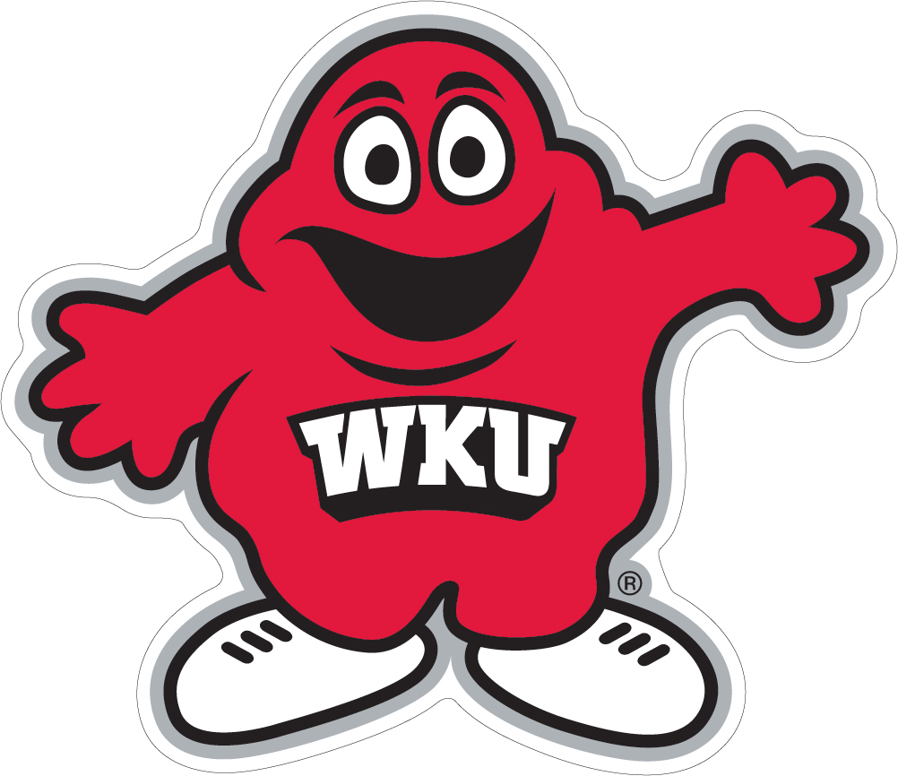
Session I (10:00 – 10:40 am)
Session Title Room Presenter(s)
Career Planning: Steps to Take Now 2004 Adrianne Browning
IFC/Panhellenic Student Panel 2081 Student Leader Panel
Mastering the Hill: How to Get the Most out of your WKU Experience 2113 Emily Pride Sutton (ΑΟΠ)
Remembering Your Why 2123/2124 Professor David Serafini (ΣΦΕ)
FACTS and Snacks 3003/3004 Michael Crowe (ΚΑΨ) & Melanie Evans (ΑΓΔ)
Money Skills: Things that Most College Students Learn a Little Too Late 3005 Zach Jones
Neurodiversity & Inclusion in Greek Life 3006/3007 Michelle Elkins & Hendrix Brakefield
Lead with Integrity, Inclusivity, and Impact 3020 Ena Demir
Let’s Talk About Mental Health 3023 Colby Clark (ΣΧ) & Maria Genduso
Conquering Credit with U. S. Bank: Explore How Credit Plays a Role in Your Everyday Life. 3024 Clay Phillips (ΛΧΑ) & Meghan White
Inspiration or Plagiarism? Academic Integrity at WKU 3025 Laura DeLancey & Sara McCaslin (ΑΓΔ)

Session II (10:50– 11:30 am)
Session Title Room Presenter(s)
Career Planning: Steps to Take Now 2004 Adrianne Browning
IFC/Panhellenic Student Panel 2081 Student Leader Panel
Mastering the Hill: How to Get the Most out of your WKU Experience 2113 Emily Pride Sutton (ΑΟΠ)
Remembering Your Why 2123/2124 Professor David Serafini (ΣΦΕ)
FACTS and Snacks 3003/3004 Michael Crowe (ΚΑΨ) & Melanie Evans (ΑΓΔ)
Money Skills: Things that Most College Students Learn a Little Too Late 3005 Zach Jones
Neurodiversity & Inclusion in Greek Life 3006/3007 Michelle Elkins & Hendrix Brakefield
Lead with Integrity, Inclusivity, and Impact 3020 Ena Demir
Let’s Talk About Mental Health 3023 Colby Clark (ΣΧ) & Maria Genduso
Conquering Credit with U. S. Bank: Explore How Credit Plays a Role in Your Everyday Life. 3024 Clay Phillips (ΛΧΑ) & Meghan White
Inspiration or Plagiarism? Academic Integrity at WKU 3025 Laura DeLancey & Sara McCaslin (ΑΓΔ)
42nd Annual Greek Leadership Symposium

Welcome (9:15 – 9:25 am) DSU Auditorium Anne Simpson
Order of Omega GLS Chair

Keynote (9:25 – 9:50 am) DSU Auditorium Olivia Higgins Biven (ΧΩ)
Director of Brand Marketing and Licensing,
Louisville Athletics

Session I (10:00 – 10:40 am) & Session II (10:50 – 11:30 am)
Session Title Room Presenter(s)
Student Leader Panel: Leadership, Internships, & Personal Stories 2081 Sarah Vlahakos (ɸΜ), Breanna Creekmore
(ΚΔ), Calleigh Powell (ΩɸΑ), Harrison
Snyder (ΣΧ), Avery Wells (ΦΒΣ), Jada
Webster (ΔΣΘ), Dylan Cobb (FH)

Conquering Credit 2113 Clay Phillips (ΛΧΑ) Client Relationship
Consultant at U.S. Bank

PR & Personal Branding 3003/04 Savannah Gillispie, Assistant Director of
Global Communications and Recruitment at
WKU Global Learning & International Affairs

Translating Greek Experiences to Real World 3005 Kara Beth Robertson (ΧΩ), Recruiter at
Calculated Hire

Balanced Living and Wellness 3006/07 Amy Wininger, Student Wellness Navigator at
WKU College of Health and Human Services

Why Do Couples Break Up? 3020 Thomas Weakley, WKU Professor, Organizational
Leadership Department, CRU Staff

Money Management 3023 Lily Martin, Financial Coach at WKU Center
for Financial Success
Kaylie Wise, Financial Coach at WKU Center
for Financial Success

Keeping it💯 3024 Ena Demir, Executive Director & Title IX
Coordinator at WKU Office of Institutional
Equity
Melanie Evans (ΑΓΔ), Coordinator for Sexual
Assult Services and Student Conduct at
WKU Office of Student Conduct

Leadership and Resiliency 3025 SFC Eric Vincent (ROTC), Kentucky Army
National Guard On Campus Recruiter at WKU

